

Name: _____________________________________( ) Date : ___________

Class: Sec 1E ______

**Chapter 9: Rate and Speed (Math Task using micro:bit)**

**Getting ready:**

1. Each student will collect a laptop and a micro:bit from the computer lab.
2. Parts and features of micro:bit

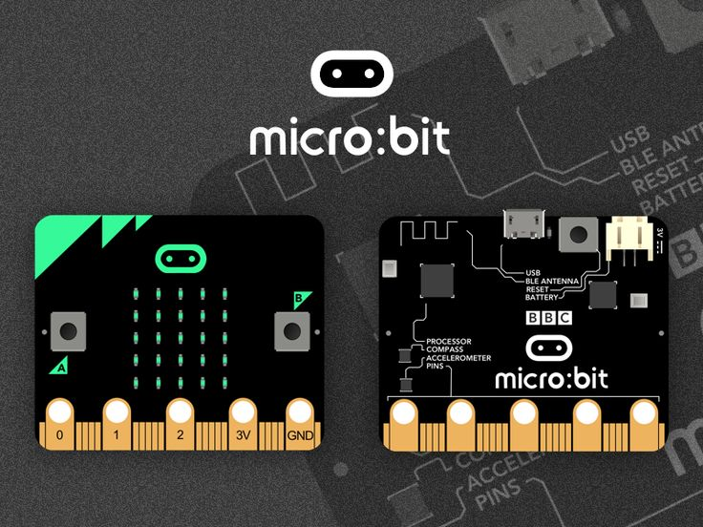

Pins 0 to 2, 3V and GND

Reset button

Compass

Accelerometer

Bluetooth connection

Input buttons A & B

25 LEDs

**Figure 1: Parts of a micro:bit**

|  |  |
| --- | --- |
| 25 LEDs | 25 light emitting diodes (LEDs) can be turned on or off to form shapes, numbers and messages and the brightness can be controlled. |
| Input buttons A & B | Buttons A and B are a form of input. The micro:bit can detect when either one or both of the buttons are pressed or released and be programed to act on that. |
| Pins | Pins labelled 0, 1, 2 are a form of input or output and can be connected to external devices such as the buzzer, servo, moisture sensors. Pin 3V is the voltage pin. GND is the ground pin. |
| Bluetooth connection | A low energy Bluetooth connection can be used to interact with other Bluetooth enabled devices. |
| Accelerometer | The accelerometer detects changes in the micro:bit’s speed. The micro:bit can detect a few standard actions, e.g., shake, tilt and free-fall. |
| Compass | A compass on the micro:bit can detect magnetic field such as the Earth’s magnetic field. As such, it is possible to detect the direction the micro:bit is facing and movement in angles. |
| Reset button | To reset the micro:bit and start the program again. |

1. After logging into the laptop, connect the small end of the USB cable to the micro USB port on your micro:bit and connect the other end of the USB cable to a USB port on your computer. Your computer should recognise your micro:bit as a new drive.

|  |  |
| --- | --- |
| Small end of USB cable  Big end of USB cable  Battery holder  Image result for how to connect micro bit to laptop |  |

**Figure 2: micro:bit, battery holder & USB cable connection**

1. Launch Google Chrome and enter the URL <http://microbit.org/code/> and the web page as shown in Figure 3 below will be displayed.

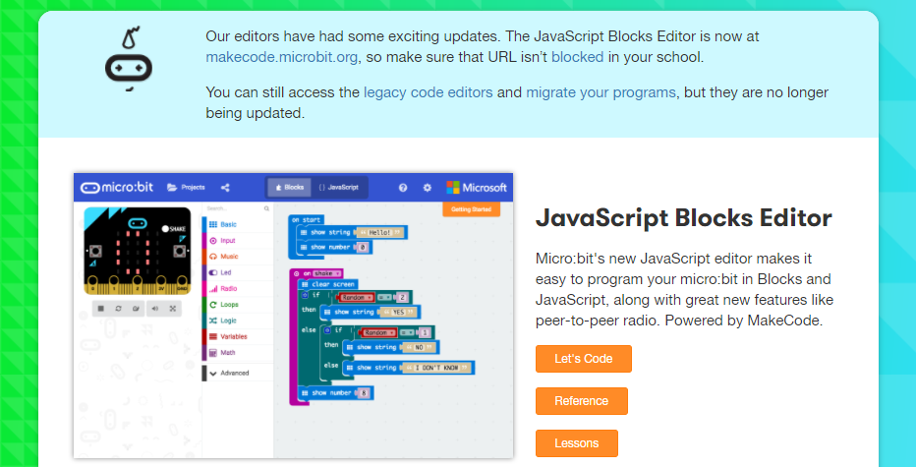

**Figure 3: micro:bit JavaScript Blocks Editor**

1. Click on Let’s Code. Then you will see the blocked-based programming environment as shown in Figure 4.
2. Blocked-based programming environment:

Blocks

Javascript

Projects

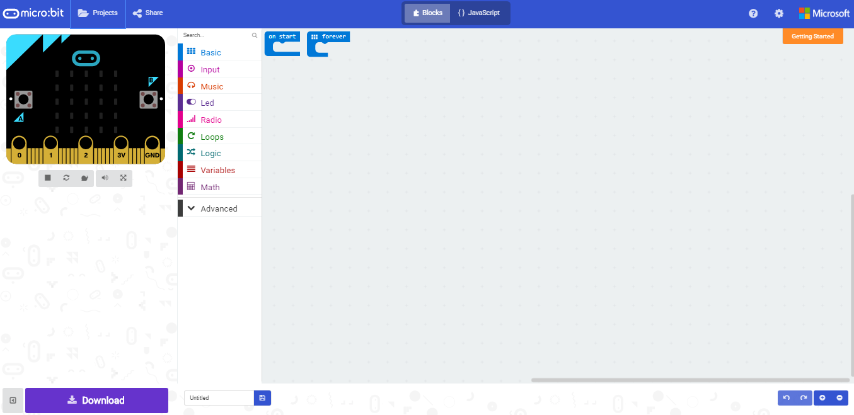

Code menu (coloured coded)

Download

Project title

Visual results

Programming area

**Figure 4: Block-based programming environment**

1. Program, download and transfer the work you’ve done:

* You can drag the blocks from the code menu and drop them into the programming area where the blocks will snap together.
* There are two views on your editor – Blocks and Javascript. If you click on Javascript, you will see that the editor automatically convert your block codes to Javascript. Click on Blocks again to go back to Block view. You may edit your program and see how your program works using the visual results on the left.
* Let’s have a little exercise!
  + Click on the [Basic] menu and drag the [show leds] block to the programming area and insert it into the [on start] block.
  + Click on the LEDs to display the picture of a dog.
  + Try changing the picture by clicking other LEDs or dragging a [pause (ms)] block followed by an [show icon] block or other block(s) into the [on start] block. What happen when these blocks are moved into the [forever] block?
  + Look at the view results area to see how your program works.
  + 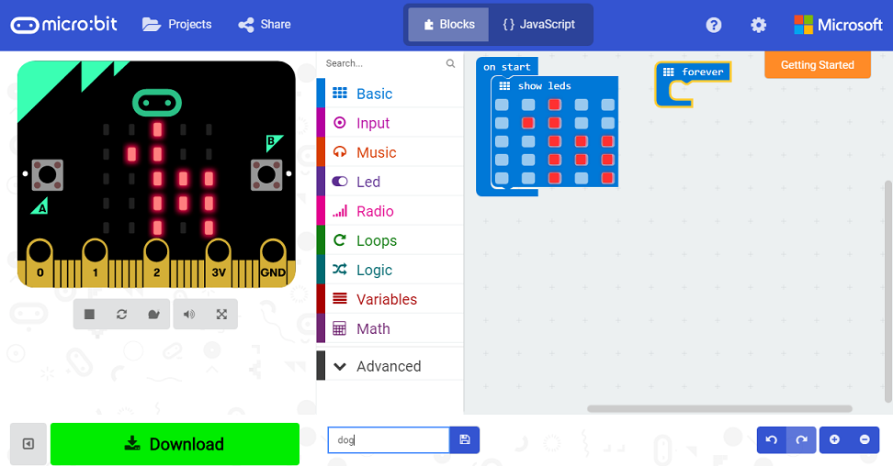

**Figure 5: A simple program to show a picture of a dog**

* After you are satisfied with the program you have done, enter the project title (you may call it dog) at the bottom left and click Download. A hex file will be created in the Downloads folder.
* Go to Downloads folder in Window Explorer to copy and paste the hex file into the micro:bit folder. The LED on the back of your micro:bit will flash quickly during the transfer.
* Once transferred, the code will run automatically on your micro:bit. To rerun your program, press the reset button on the back of your micro:bit.

**Activity 1: Step Challenge!**

1. For this activity, you will challenge your classmates to see who is the fittest and fastest. Your teacher will assign a group to you. There should be not more than 10 students per group. Students in the same group will compete against each other in this Step Challenge!
2. The program has already been done for you so you just need to copy it into your micro:bit. Log into Ask and Learn Portal and click on Announcements. Select Organization All Announcements from the drop-down list. Look for the subject Micro:bit files for 1E[x] and download the file StepChallenge1E[xy].hex and copy it to your micro:bit drive. In [x] and [xy], x refers to your class (for 1E1, x = 1, 1E2, x = 2 etc.) and y refers to the group assigned to you within the same class.
3. After you have copied the hex file into your micro:bit drive, disconnect the micro:bit from the USB port. Put the batteries into the battery holder and connect it to the micro:bit. Follow the instructions below to run the program.

**Instructions:**

Press RESET button at the BACK of the micro:bit (See Figure 1) to restart the whole activity as a group.

Press Button A to start the Step Challenge.

Press Button A and B together to reset the time and steps count.

You may wear the micro:bit on your arm and walk around or hold the mico:bit in your palm and shake the micro:bit to simulate walking.

**Let’s GO!**

1. Press A to start the Step Challenge and start WALKING or SHAKING! Steps count will be shown on the LED display on the micro:bit.
2. The first person to reach the steps target of 50 will be the winner and a message will be sent to all the micro:bits in the same group. The winner will see the message “E[xy] WINNER [time]” while the losers will see “E[xy] OVER [time] where [xy] indicate the class and group and [time] indicates the winning time (in seconds, 3 decimal places).
3. You are required to record the winner’s name and the winning time in the table below and complete the table.
4. Press RESET button at the BACK of micro:bit to restart the whole activity as a group.
5. To have another challenge, repeat Steps 1 to 4.

|  |  |  |  |  |  |
| --- | --- | --- | --- | --- | --- |
| **Challenge** | **Winner name** | **No. of steps** | **Winning time (seconds)** | **Speed = No. of steps/time** | |
| **(steps/second)** | **(steps/ minute)** |
| **1** |  | 50 | 48.591 | 1.028997...≈1.03 | 61.739828…≈61.7 |
| **2** |  | 50 | 46.773 | 1.068992…≈1.07 | 64.139567…≈64.1 |
| **3** |  | 50 | 41.648 | 1.200537…≈1.20 | 72.032270…≈72.0 |

1. By looking at the Walking Pace Chart below, which level does the fastest winner belong to?

Very inactive____________________________________________________________________

WALKING PACE CHART  
  
LEVEL 1: VERY INACTIVE: 80-100 steps per minute   
LEVEL 2: LIGHTLY ACTIVE: 120 steps per minute   
LEVEL 3: MODERATELY ACTIVE: 130 steps per minute   
LEVEL 4: ACTIVE: 140 steps per minute   
LEVEL 5: VERY ACTIVE: 150 steps per minute  
LEVEL 6: EXCEPTIONALLY ACTIVE: 160 steps per minute   
LEVEL 7: ATHLETE: 170 steps per minute  
LEVEL 8: ATHLETE: 180 steps per minute  
LEVEL 9: ATHLETE: 190 steps per minute

1. The recommended activity level based on steps per day is:

SEDENTARY (INACTIVE): less than 5000 steps per day

LOW ACTIVE: 5000 to 7499 steps per day

SOMEWHAT ACTIVE: 7500 to 9999 steps per day

ACTIVE: 10000 steps or more per day

HIGHLY ACTIVE: 12500 steps or more per day

Assuming the fastest winner of this challenge is able to walk continuously at the same speed, how long will it take her to achieve 10000 steps?

10000/72.032 = 138.827…≈139 min________________________________________________

**Sharing and Reflections**

Share and compare your readings and results with your classmates.

What have you learned from this activity?

**Activity 2: Find the rate of revolution of a servo**

**Set up:**

1. Each pair of students will need a servo, three male-male jumper wires (recommended colours are yellow, red and black. Choose the closest colour if any of these 3 colours is unavailable), some screws, a micro:bit and a laptop. See Figure 6.

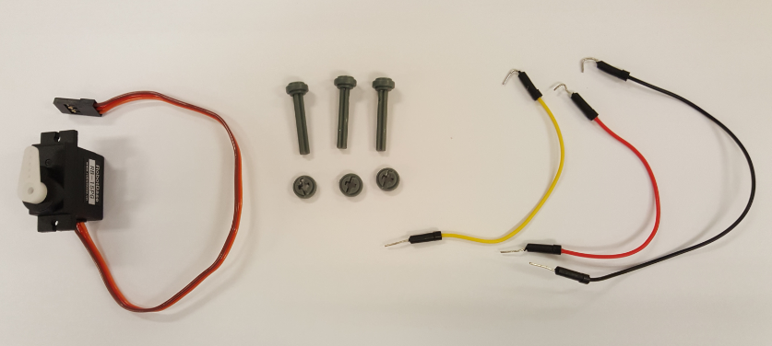

**Figure 6: Servo, screws, jumper wires**

1. Set up the project as shown in Figure 7.
   1. Bend one end of the jumper wires. Hook the bent end of the wires on the pins (Yellow on pin 0, red on pin 3V and black on pin GND) and fasten the wires using the screws.
   2. Connect the unbent end of the wires to the wires on the servo (yellow to orange, red to red and black to brown).
2. Go to Ask and Learn Portal to download the file servoSpeed.hex and copy it to the micro:bit drive.
3. Disconnect the micro:bit from the USB port.

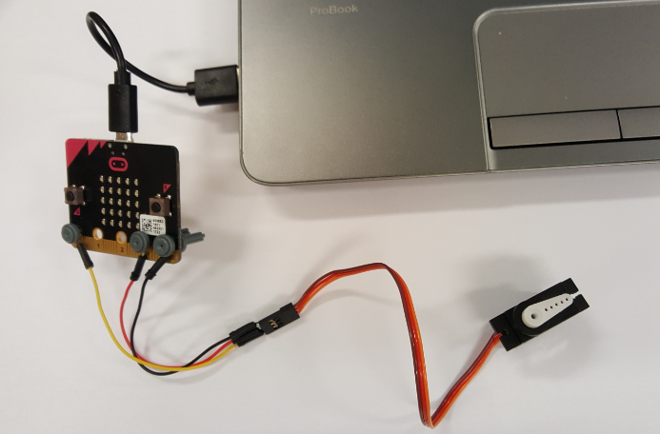

**Figure 7: Micro:bit with Servo**

**Instructions:**

Press Button A to select speed 1, 2 or 3 (1 being the fastest and 3 being the slowest).

Press Button B to start timing, turning the servo and counting the number of revolutions (1 revolution is a complete turn from 0 to 180 degrees and 180 back to 0 degree).

Press Button A and B together to reset the time and number of revolutions.

**Let’s GO!**

1. Press A to select speed 1.
2. Press B to start servo turning.
3. Press B again to stop servo turning. Number of revolutions and time taken in seconds (3 decimal places) will be shown thrice. Students are to record these in the table below. Calculate the rate of revolution of the servo.
4. Press A and B to reset the time and number of revolutions.
5. Repeat Steps 1 to 4 for speed 2 and 3.

|  |  |  |  |  |
| --- | --- | --- | --- | --- |
| **Speed** | **No. of revolutions** | **Time (seconds)** | **Rate (revolutions/second)** | **Rate (revolutions/minute)** |
| **1** | 20 | 22.322 | 0.8959…≈0.896 | 53.758…≈53.8 |
| **2** | 20 | 32.577 | 0.6139…≈0.614 | 36.835…≈36.8 |
| **3** | 20 | 40.383 | 0.4952…≈0.495 | 29.715…≈29.7 |

The servo simulates the sprinkler used in an automatic watering system used in gardens. Given that a sprinkler sprinkles 2.4 litres/min of water and a small garden needs 12 litres of water each day.

1. For how long do you need to turn on the sprinkler each day?

12/2.4 = 5 min___________________________________________________________

1. (i) How many revolutions does the slowest sprinkler turn each day?

29.715 x5 = 148.575≈149 revolutions (3 s.f)_____________________________________

(ii) How much water is put out in each revolution? Round off your answer to the nearest millilitres.

12/148.575 = 0.08076…litres ≈ 81 millilitres (nearest millilitres)_____________________

**Sharing and Reflections**

Share and compare your readings and results with your classmates.

What have you learned from this program?

**(Optional) Activity 3: Find the buzzer’s beat rate in beats per minute**

**Set up:**

1. Each pair of students should have some screws, three male-male jumper wires (yellow, red and black), one 3-coloured cable, a buzzer, a micro:bit and a laptop.
2. Set up the connection to your micro:bit as shown in Figure 8 below. Note that for the 3-coloured cable, the yellow, red and black wire should be connected to the S, + and – pin respectively on the buzzer. The other end of the 3-coloured wire is connected to the pins 0, 3V and GND on the micro:bit via the yellow, red and black wires respectively.

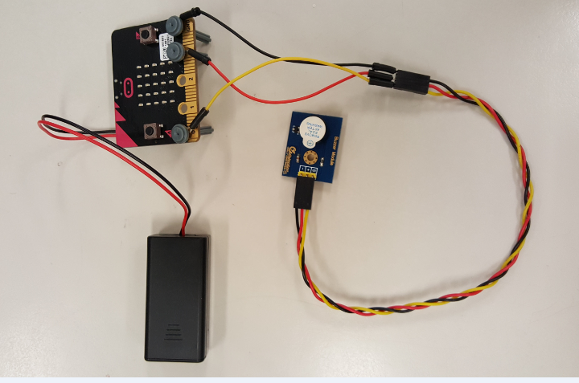

**Figure 8: Micro:bit with buzzer**

1. Connect the micro:bit to the laptop using the USB cable.
2. Go to Ask and Learn Portal to download the file buzzerSpeed.hex and copy it to the micro:bit drive.
3. Disconnect the micro:bit from the USB port.

**Instructions:**

Press Button A to set choice of speed 1, 2 or 3 (1 being the fastest and 3 being the slowest).

Press Button B to start or stop stopwatch timing, heart beating and buzzer beeping.

Press Button A and B together to reset the choice and stopwatch.

**Let’s GO!**

1. Press A to set choice of speed to 1.
2. Press B to start stopwatch timing, heart beating and buzzer beeping. You are required to manually count the number of heart beats or buzzer beeps while the micro:bit keeps track of time in seconds. Once started, the picture of the heart will start blinking and buzzer beeping.
3. Press B to stop stopwatch timing, heart beating and buzzer beeping. The number of seconds (in 3 decimal places) will be displayed thrice. You are to record the number of heart beats or buzzer beeps and time in seconds in the table below. Calculate the beating or beeping rate.
4. Press A and B to reset choice of speed and stopwatch.
5. Repeat Steps 1 to 4 for speed 2 and 3.

|  |  |  |  |  |
| --- | --- | --- | --- | --- |
| **Speed choice** | **No. of beats** | **Time (seconds)** | **Rate (beats/second)** | **Rate (beats/minute)** |
| **1** | 20 | 16.784 | 1.1916…≈1.19 | 71.496…≈71.5 |
| **2** | 20 | 28.285 | 0.7070…≈0.707 | 42.425…≈42.4 |
| **3** | 20 | 44.160 | 0.4528…≈0.453 | 27.173…≈27.2 |

Here follows a list of common tempo markings. The beats per minute (bpm) values are very rough approximations for **4/4** time.

* *Larghissimo* – very, very slow (24 bpm and under)
* *Grave* – very slow (25–45 bpm)
* *Largo* – broadly (40–60 bpm)
* *Lento* – slowly (45–60 bpm)
* *Larghetto* – rather broadly (60–66 bpm)
* *Adagio* – slow and stately (literally, "at ease") (66–76 bpm)
* *Adagietto* – slower than *andante* (72–76 bpm)
* *Andante* – at a walking pace (76–108 bpm)

1. Which tempo markings do the rates in the table above belong to?

Speed 1 – Adagio, Speed 2 – Largo, Speed 3 - Grave___________________________________

1. If a song is played in andante tempo,
   1. what is the minimum number of beats in 30 seconds? 76/2 = 38 beats.
   2. What is the minimum amount of time taken, in seconds, to play 90 beats? To achieve minimum time, tempo must be highest. So, 90/108 x 60 = 50 seconds

**Sharing and Reflections**

Share and compare your readings and results with your classmates.

What have you learned from this program?

What else would you like to learn using micro:bit?

**Sec. 1 Post-Exams Program – Rate and Speed (Math Task Using Micro:bit)**

Materials needed: For each pair of student, 1 laptop, 1 micro:bit, screws, 3 male-male wires, one 3-coloured wire, 1 buzzer, 1 servo, notes.

|  |  |  |
| --- | --- | --- |
| **Time** | **Description** | **Remarks** |
| 20 mins  20 mins  10 mins | 1. Introduction to Micro:bit  * What is a Micro:bit and what are its parts and features? * Do a simple program to learn how to copy a program from laptop into Micro:bit and run the program on the Micro:bit  1. Activity 1: Step Challenge  * Follow instructions on the notes to carry out the activity and calculate the speed in steps per second and steps per minute. Calculate time based on steps given and speed found.  1. Sharing of results, Reflections  * What have students learned? | Admin & logistics  - Give out notes  - Collect and set up laptop, Micro:bit |
| **RECESS** | | |
| 20-30 mins  20 mins  10-20 mins | 1. Activity 2: Rate of revolution   Follow instructions on the notes to carry out the activity and calculate the rate of revolution of a servo (in rev/s & rev/min). Calculate time=vol/rate, no. of revolutions = rate x time, find vol per revolution.   1. (Optional) Activity 3: Buzzer’s beat rate  * Follow instructions on the notes to carry out the activity and calculate the buzzer’s beat rates. Learn about tempo markings, how to calculate beats given time and vice-versa based on rates given.  1. Sharing of results, Reflections and Packing up  * What have students learned? * What else do students want to learn or find out? | Other than the above devices, these are required: screws, 3 jumper wires, servo  3-coloured wire, buzzer |